http://www.informit.com/articles/article.aspx?p=2216988

Java SE 8's New Compact Profiles and Integer APIs

- By Jeff Friesen
- May 19, 2014
📄 Contents
␡
- Compact Profiles
- Unsigned Integer API
- Integer Arithmetic Overflow/Underflow Detection API
- ⎙ Print
- + Share This
Page 1 of 3 Next >
Java SE 8 offers many useful features that can increase your productivity. Lambdas, the Streams API, and Nashorn may be more widely known, but the Java SE 8 release also includes compact profiles, an API for unsigned integers, and an API for integer arithmetic overflow/underflow detection. Jeff Friesen introduces you to these three lesser-known features.
Like this article? We recommend 

Like this article? We recommend
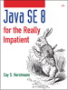Java SE8 for the Really Impatient: A Short Course on the Basics
Learn More Buy

Like this article? We recommend
Java SE8 for the Really Impatient: A Short Course on the Basics
Learn More Buy
Java SE 8 brings many new and exciting features to Java developers. Lambdas, the Streams API, and the Nashorn JavaScript engine have gathered much of the attention, but this Java release also offers various small but important features that can make your life easier. This article introduces you to three of them: compact profiles, API support for unsigned integers, and API support for detecting overflows/underflows from integer arithmetic operations.
I developed this article's applications with the 64-bit version of JDK 8 build 132 on a Windows 7 platform. You can download the code from this article here.

Compact Profiles
Each Java SE release increases the size of Java's footprint, making it extremely difficult—if not impossible—to deploy the complete Java runtime on certain small devices. To address this problem, the Java community has requested that Java be subsetted, allowing you to deploy only those Java components required by an application, instead of deploying the entire runtime platform.
Subsetting offers several advantages:
- A smaller runtime platform can be optimized to start faster and perform better.
- Shrinking the runtime footprint increases the feasibility of bundling runtimes with individual applications.
- Fewer computational resources are required, making it possible to deploy Java on a wider variety of smaller devices.
Oracle has been reluctant to subset because subsetting fragments the Java platform, and fragmentation is a big problem for Android. Instead, Oracle is working to create a more modular Java platform through Project Jigsaw. However, because Project Jigsaw won't arrive until Java SE 9, Oracle has introduced compact profiles as an interim solution.
A compact profile is a collection of packages that are a subset of the Java platform. Java SE 8 defines three compact profiles, named compact1, compact2, and compact3. Each profile is a superset of its predecessor. For example, compact2 contains all of the compact1 packages as well as introducing its own packages. The following table identifies the packages introduced by each profile.

Table 1: Compact Profiles and Their Packages
Packages in compact1 | Packages in compact2 | Packages in compact3
java.io  java.lang  java.lang.annotation  java.lang.invoke  java.lang.ref  java.lang.reflect  java.math  java.net  java.nio  java.nio.channels  java.nio.channels.spi  java.nio.charset  java.nio.charset.spi  java.nio.file  java.nio.file.attribute  java.nio.file.spi  java.security  java.security.cert  java.security.interfaces  java.security.spec  java.text  java.text.spi  java.time  java.time.chrono  java.time.format  java.time.temporal  java.time.zone  java.util  java.util.concurrent  java.util.concurrent.atomic  java.util.concurrent.locks  java.util.function  java.util.jar  java.util.logging  java.util.regex  java.util.spi  java.util.stream  java.util.zip  javax.net  javax.net.ssl  javax.script  javax.security.auth  javax.security.auth.callback  javax.security.auth.login  javax.security.auth.spi  javax.security.auth.x500  javax.security.cert | java.rmi  java.rmi.activation  java.rmi.dgc  java.rmi.registry  java.rmi.server  java.sql  javax.rmi.ssl  javax.sql  javax.transaction  javax.transaction.xa  javax.xml  javax.xml.datatype  javax.xml.namespace  javax.xml.parsers  javax.xml.stream  javax.xml.stream.events  javax.xml.stream.util  javax.xml.transform  javax.xml.transform.dom  javax.xml.transform.sax  javax.xml.transform.stax  javax.xml.transform.stream  javax.xml.validation  javax.xml.xpath  org.w3c.dom  org.w3c.dom.bootstrap  org.w3c.dom.events  org.w3c.dom.ls  org.w3c.dom.views  org.xml.sax  org.xml.sax.ext  org.xml.sax.helpers | java.lang.instrument  java.lang.management  java.security.acl  java.util.prefs  javax.annotation.processing  javax.lang.model  javax.lang.model.element  javax.lang.model.type  javax.lang.model.util  javax.management  javax.management.loading  javax.management.modelmbean  javax.management.monitor  javax.management.openmbean  javax.management.relation  javax.management.remote  javax.management.remote.rmi  javax.management.timer  javax.naming  javax.naming.directory  javax.naming.event  javax.naming.ldap  javax.naming.spi  javax.security.auth.kerberos  javax.security.sasl  javax.sql.rowset  javax.sql.rowset.serial  javax.sql.rowset.spi  javax.tools  javax.xml.crypto  javax.xml.crypto.dom  javax.xml.crypto.dsig  javax.xml.crypto.dsig.dom  javax.xml.crypto.dsig.keyinfo  javax.xml.crypto.dsig.spec  org.ietf.jgss
The Java SE 8 javac compiler tool has a new -profile option that lets you compile an application's source code against one of the compact profiles. If the source code references a package not supported by the profile, javac outputs an error message. For example, consider the trivial class declaration in Listing 1.

Listing 1: CPDemo.java.
import java.sql.Statement;

public class CPDemo
{
Statement stmt;
}
You can easily compile this source code, which must be stored in a file named CPDemo.java, as follows:
javac CPDemo.java
Because the java.sql package is a member of the compact2 profile, which is a subset of compact3, either of the following commands will also compile Listing 1:
javac -profile compact2 CPDemo.java
javac -profile compact3 CPDemo.java
However, if you attempt to compile Listing 1 against the compact1 profile, which doesn't support java.sql, you'll observe the following error messages:
CPDemo.java:1: error: Statement is not available in profile 'compact1'
import java.sql.Statement;
^
CPDemo.java:5: error: Statement is not available in profile 'compact1'
Statement stmt;
^
2 errors
Java SE 8 also introduces the jdeps tool for listing the dependencies in a classfile, a directory of classfiles, or a JAR file of classfiles. For example, the following command executes jdepsagainst CPDemo.class:
jdeps CPDemo.class
This command generates the following output, which shows that CPDemo.class is dependent on the runtime JAR file, along with the java.lang and java.sql packages:
CPDemo.class -> C:\progra~1\java\jdk1.8.0\jre\lib\rt.jar
<unnamed> (CPDemo.class)
-> java.lang
-> java.sql
You can obtain more information by specifying one or more options. For example, the following command also outputs the types in each referenced package and the profile to which the package belongs:
jdeps -verbose -P CPDemo.class
You should observe the following output (reformatted for readability):
CPDemo.class -> C:\progra~1\java\jdk1.8.0\jre\lib\rt.jar (compact2)
CPDemo -> java.lang.Object compact1
CPDemo -> java.sql.Statement compact2
The -profile option and the jdeps tool help you ensure that your application conforms to a specific compact profile. Java SE 8 Embedded offers a jrecreate tool that lets you create a smaller Java platform (for ARM and other embedded devices) that conforms to this profile. Check out Jim Connors' "Demonstrating Compact Profiles" video to learn more.

Compact Profiles
The Java Development Kit (JDK) consists of the Java Language, development tools such as Java compiler, debugger, etc., and the Java Runtime Environment (JRE). The JRE is a subset of JDK and it consists of libraries, the Java virtual machine, and deployment toolkits. Libraries in the JRE can be subdivided into the following four categories:
- Lang and util base libraries
- Other base libraries
- Integration libraries
- User interface toolkits
Before Java SE 8, the JRE distribution was based on the all-or-nothing strategy. There was only one bundle of
the JRE for a platform that contained libraries in all the four categories. This was a problem for resource-constrained devices. Suppose you had developed an application for Raspberry PI that uses only the lang and util base libraries. However, you had to deploy the full JRE that contained libraries in all the four categories. This simply used more space on the device than needed.
Java SE 8 introduced the concept of compact profiles that is a way to define subsets of the JRE libraries. A JRE bundle may contain one of those subsets of libraries or all libraries. The JRE containing a subset of the libraries is called a compact profile; the JRE containing all libraries is called the full JRE as it used to be before Java SE 8. Now, you can develop applications using JDK 8 and deploy them using one of the compact profiles to memory-constrained small devices. You can have a compact profile that may take as little as 11MB of space on a device running on Linux. Java SE 8 defines three compact profiles that are named as follows:
  - compact1
  - compact2
  - compact3
Each profile specifies a set of Java API packages. Any packages not contained in the three compact profiles are part of the full JRE. Table C-1 lists the high-level library names in each compact profile and the full JRE.
www.it-ebooks.info
759
Appendix C ■ CompACt profiles
Table C-1.
Full JRE
compact3
compact2 compact1
List of the Library Names for Compact Profiles and the Full JRE
Accessibility CORBA
Image I/O JAX-WS
Print Service Swing Instrumentation Security
JDBC
Collections
Date and Time Internationalization Logging
Ref Objects Scripting Versioning
AWT
Drag and Drop
Input Methods JNI
RMI-IIOP
JMX
XML JAXP
RMI
Concurrency Extension Mechanism JAR
Networking Reflection
Security
ZIP
Beans IDL
Java 2D Preferences Sound
Management
XML JAXP
Core (java.lang.*) Input/Output
JNDI
Override Mechanism Regular Expressions Serialization
■ Tip
implements the entire JVm and the entire Java language. sub-setting for a profile happens only for the packages from the Java libraries, not other parts of the Jre.
Table C-2 contains the list of packages added in each profile. Note that the list of packages is additive. That is, the compact2 profile contains all packages from the compact1 profile and the packages listed under the compact2 profile; the compact3 profile contains all the packages in the compact1 and compact2 profiles and the packages listed for the compact3 profile. In other words, compact2 is a superset of compact1; compact3 is a superset of compact2; and, the full JRE is a superset of compact3.
the full Jre (the complete Java se platform) is not considered a profile. A profile, even the smallest one,
760
www.it-ebooks.info
Table C-2. List of Packages in the compact1, compact2, and compact3 Profiles
compact2 Additions
compact1
Appendix C ■ CompACt profiles
compact3 Additions
java.lang.instrument java.lang.management
java.security.acl java.util.prefs javax.annotation.processing
javax.lang.model javax.lang.model.element javax.lang.model.type javax.lang.model.util
javax.management javax.management.loading
javax.management.modelmbean java.rmi
java.rmi.activation
java.rmi.dgc
java.rmi.registry java.rmi.server java.sql javax.rmi.ssl javax.sql javax.transaction javax.transaction.xa javax.xml
java.io
java.lang java.lang.annotation java.lang.invoke java.lang.ref java.lang.reflect java.math
javax.management.monitor
javax.management. openmbean
javax.management.relation
javax.management.remote
javax.management.remote. rmi
javax.management.timer javax.naming javax.naming.directory javax.naming.event
javax.naming.ldap javax.naming.spi
javax.security.auth.kerberos javax.xml.datatype javax.xml.namespace javax.xml.parsers javax.xml.stream javax.xml.stream.events javax.xml.stream.util javax.xml.transform javax.xml.transform.dom javax.xml.transform.sax javax.xml.transform.stax javax.xml.transform.stream java.security.cert java.security.interfaces java.security.spec
java.text java.text.spi java.time java.time.chrono
javax.security.sasl javax.sql.rowset
javax.sql.rowset.serial javax.sql.rowset.spi javax.tools
javax.xml.crypto
javax.xml.crypto.dom
javax.xml.crypto.dsig
javax.xml.crypto.dsig. dom
javax.xml.crypto.dsig. keyinfo
javax.xml.crypto.dsig. spec
org.ietf.jgss javax.xml.validation javax.xml.xpath org.w3c.dom org.w3c.dom.bootstrap org.w3c.dom.events org.w3c.dom.ls org.xml.sax org.xml.sax.ext org.xml.sax.helpers
java.util.regex java.util.spi java.util.stream java.util.zip javax.crypto javax.crypto.interfaces javax.crypto.spec
(continued) 761
www.it-ebooks.info
Appendix C ■ CompACt profiles TableC-2. (continued)
java.net
java.nio java.nio.channels java.nio.channels.spi java.nio.charset
java.nio.charset.spi java.nio.file java.nio.file.attribute java.nio.file.spi java.security
java.time.format java.time.temporal java.time.zone java.util java.util.concurrent
java.util.concurrent.atomic java.util.concurrent.locks java.util.function java.util.jar java.util.logging
javax.net
javax.net.ssl
javax.script
javax.security.auth
javax.security.auth. callback
javax.security.auth.login javax.security.auth.spi javax.security.auth.x500 javax.security.cert
The JDK 8 contains several enhancements to development tools to support developing applications targeting a specific compact profile. It has also added new tools such as jdeps to analyze the Java source code for dependencies on compact profiles. I will discuss those enhancements in subsequent sections.
Before the Java SE Embedded 8, different JRE bundles were made available for downloads targeting different embedded platforms for small devices. Beginning Java SE Embedded 8, Oracle does not provide JRE bundles for downloads; rather, it provides Java development kits for Java SE Embedded 8 (also called EJDK 8) that enable you to create custom JRE bundles containing a specific compact profile on the specific embedded platform. I will discuss EJDK 8 in detail in the “Creating Custom JREs using the EJDK” section.
Enhancement in the javac Command
In JDK 8, you can compile source code targeting one of the compact profiles or the full JRE. The option –profile is used with the javac command to specify one of the compact profiles: compact1, compact2, or compact3. Absence of this option assumes the full JRE. The javac command checks whether the APIs used in the source code are available in the specified profile. The following command compiles Welcome.java targeting the compact1 profile:
javac –profile compact1 Welcome.java
If you are using the NetBeans IDE to develop your Java application, you can choose the profile option for the Java compiler in the project properties dialog as shown in Figure C-1. To open the project properties dialog, right-click the project and select the Properties option. Select one of the profiles in the Profiles drop-down field.
762
www.it-ebooks.info
} }
JFrame frame = new JFrame("Compact Profiles");
frame.setSize(300, 300);
frame.setVisible(true);
www.it-ebooks.info
Appendix C ■ CompACt profiles
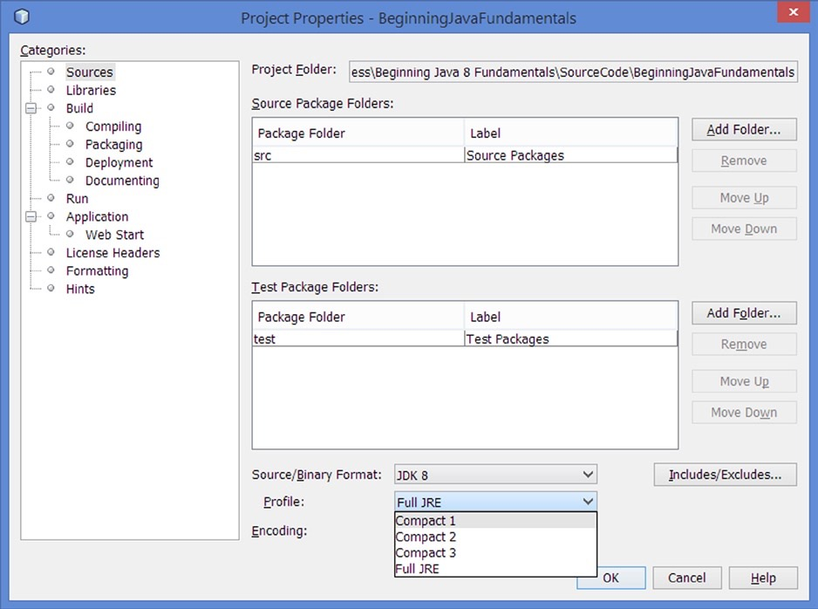
Figure C-1. Setting the -profile option for the Java compiler in the NetBeans IDE for a Java project
If the Java source code uses Java SE APIs outside the specified profile, the javac command generates an error.
Consider the code for the SwingTest and RowSetTest classes as shown in Listing C-1 and Listing C-2, respectively. Listing C-1. A SwingTest Class That Uses a Class from the javax.swing Package
// SwingTest.java
package com.jdojo.profiles;
import javax.swing.JFrame;
public class SwingTest {
public static void main(String[] args) {
763
Appendix C ■ CompACt profiles
Listing C-2. A RowSetTest Class That Uses Classes from the javax.sql Package
// RowSetTest.java
package com.jdojo.profiles;
import java.sql.SQLException;
import javax.sql.rowset.JdbcRowSet;
import javax.sql.rowset.RowSetFactory;
import javax.sql.rowset.RowSetProvider;
public class RowSetTest {
public static void main(String[] args) {
try {
RowSetFactory rsFactory = RowSetProvider.newFactory();
JdbcRowSet jdbcRs = rsFactory.createJdbcRowSet();
// More code goes here
}
catch (SQLException e) {
e.printStackTrace();
} }
The source code for the SwingTest class uses the javax.swing package that is part of the full JRE. If you try compiling the class targeting the compact3 profile, it will generate compile-time errors because the javax.swing package is available in the full JRE, not in the compact3 profile, as listed in Table C-2.
javac -profile compact3 SwingTest.java
SwingTest.java:4: error: JFrame is not available in profile 'compact3'
import javax.swing.JFrame;
^
SwingTest.java:8: error: JFrame is not available in profile 'compact3'
JFrame frame = new JFrame("Compact Profiles");
^
SwingTest.java:8: error: JFrame is not available in profile 'compact3'
JFrame frame = new JFrame("Compact Profiles");
^
3 errors
The following command using the full JRE compiles the SwingTest.java fine:
javac SwingTest.java
The following command will compile the RowSetTest class file fine as the command uses compact3 as the
-profile option that matches the packages used inside the RowSetTest class: javac –profile compact3 RowSetTest.java
}
764
www.it-ebooks.info
Enhancement in Java API Documentation
The API documentation for Java SE 8 has some enhancements that let you browse the APIs by profiles and show the profiles in which packages and classes are included. Figure C-2 shows a screenshot of the new look of the Java API documentation page. Now you can browse the Java SE APIs for a specific profile or for the full JRE.
Figure C-2. A screenshot of the profile information shown in the Java SE API documentation
When you open the API documentation using frames, three types of links are provided in the top area of the top-left frame: All Classes, All Packages, and All Profiles. Clicking the All Profiles link shows the list of profiles (marked inside a rectangle in the figure). Clicking a profile will show you all packages available in that profile. The right frame displays the list of profiles that includes the class. If a class is included only in the full JRE, the list of profiles will be shown blank.
Checking for Profile Dependencies
JDK 8 added a new class dependency analyzer tool called jdeps. It shows the package-level and class-level dependencies of Java class files. It can also analyze dependencies of classes on compact profiles to help you determine which profile you need for the deployment of your application. By default, it prints the output on the standard output. Using the –dotoutput option, you can send the output to a file in DOT file format. DOT is a plain text graph description language that is readable by humans as well as computer programs. The general syntax for using the tool is
jdeps <options> <classes>
www.it-ebooks.info
Appendix C ■ CompACt profiles
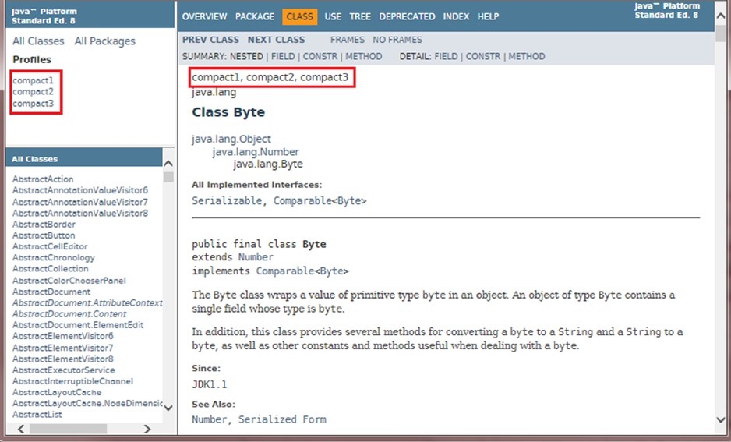
765
Appendix C ■ CompACt profiles
Here, <classes> can be a pathname to a .class file, a directory, a JAR file, or a fully qualified class name.
Table C-3 lists all the options for the jdeps tool. Table C-3. List of Options for the jdeps Tool
Option
-dotoutput <dir>
-s –summary
-v –verbose
-verbose:package
-verbose:class
-cp <path>
-classpath <path>
-p <pkgname>
-package <pkgname>
-e <regex>
-regex <regex>
-include <regex>
-P -profile
-apionly
-R
-recursive
-jdkinternals
-version
-h
-? -help
Description
Specifies the destination directory for DOT file output. Prints dependency summary only.
Prints all class level dependencies.
Prints package-level dependencies excluding dependencies within the same archive. Prints class-level dependencies excluding dependencies within the same archive. Specifies the locations where class files are searched.
Finds dependences in the specified package. This option may be specified multiple times. This option and –e option are mutually exclusive.
Finds dependences in packages matching the specified pattern. This option and –p option are mutually exclusive.
Restricts analysis to classes matching the specified pattern. It is used to filter the list of classes to be analyzed. It can be used together with -p and -e options, which apply pattern to the dependences.
Shows profile or the file containing a package.
Restricts analysis to APIs only that includes dependences from the signature of public and protected members of public classes including field type, method parameter types, returned type, checked exception types, etc.
Recursively traverses all dependencies.
Finds class-level dependences on JDK internal APIs. By default, it analyzes all classes on –cp and input files unless -include option is specified. It cannot be used with -p, -e, and -s options.
Prints the version information.
Prints a help message for the jdeps tool listing all options with a brief description.
The following command prints the dependencies for the SwingTest class:
jdeps SwingTest.class
SwingTest.class -> C:\java8\jre\lib\rt.jar
com.jdojo.profiles (SwingTest.class)
-> java.lang
-> javax.swing
766
www.it-ebooks.info
Appendix C ■ CompACt profiles The following command prints the dependencies with the profile information for the SwingTest class:
jdeps -profile SwingTest.class
SwingTest.class -> C:\java8\jre\lib\rt.jar (Full JRE)
com.jdojo.profiles (SwingTest.class)
-> java.lang compact1
-> javax.swing Full JRE
The following command prints the dependencies with the profile information for both SwingTest and RowSetTest classes:
jdeps -profile SwingTest.class RowSetTest.class
SwingTest.class -> C:\java8\jre\lib\rt.jar (Full JRE)
com.jdojo.profiles (SwingTest.class)
-> java.lang
-> javax.swing
RowSetTest.class -> C:\java8\jre\lib\rt.jar (compact3)
com.jdojo.profiles (RowSetTest.class)
-> java.lang
-> java.sql
-> javax.sql.rowset
compact1
Full JRE
compact1
compact2
compact3
The following command will create three DOT files in the mydotdir directory: SwingTest.class.dot, RowSetTest.class.dot, and summary.dot:
jdeps -profile -dotoutput mydotdir SwingTest.class RowSetTest.class The contents of the SwingTest.class.dot file will be
digraph "SwingTest.class" {
// Path: SwingTest.class
"com.jdojo.profiles" -> "java.lang (compact1)";
"com.jdojo.profiles" -> "javax.swing (Full JRE)";
}
The contents of the RowSetTest.class.dot file will be
digraph "RowSetTest.class" {
// Path: RowSetTest.class
"com.jdojo.profiles"
"com.jdojo.profiles"
"com.jdojo.profiles"
-> "java.lang (compact1)";
-> "java.sql (compact2)";
-> "javax.sql.rowset (compact3)";
}
The contents of the summary.dot file will be
digraph "summary" {
"SwingTest.class"
"RowSetTest.class"
}
-> "rt.jar"[label="Full JRE\n",fontsize=9];
-> "rt.jar"[label="compact3\n",fontsize=9];
www.it-ebooks.info
767
Appendix C ■ CompACt profiles
Creating Custom JREs Using the EJDK
Oracle provides Java development kits for Java SE Embedded 8 (also called EJDK 8), enabling you to create custom JRE bundles containing packages for a specific compact profile. Note that the EJDK is not a development kit used for Java application development; rather, it is a tool to create a compact profile or the full JRE for specific platforms and CPU architectures. EJDK 8 is available for the following Java SE Embedded platforms/CPU architectures:
- Linux/ARMv7 - VFP, HardFP ABI, Little Endian
- Linux /ARMv6/7- VFP, SoftFP ABI, Little Endian
- Linux/ARMv5 - Headless - SoftFP ABI, Little Endian
- Linux/ Power Architecture - Headless - e600 CPU variant with a Classic Floating Point Unit
- Linux /Power Architecture - Headless - e500v2 with double-precision SPE Floating Point Unit
- Linux /x86 Small Footprint - Headless
■ Note
custom Jres for Windows and mac using eJdKs. However, you can download and use eJdKs on Windows to create custom Jres for the listed platforms (linux) and the CpU architectures.
At the time of this writing, eJdKs support creating custom Jres only on linux platform. You cannot create
Installing EJDK
You need to perform the following steps to install EJDK:
Make sure you have installed JDK or JRE for Java SE 8 on your machine. One of them (JDK or JRE) is required when you use EJDK 8.
Download the EJDK installation file from the download page, www.oracle.com/technetwork/ java/embedded/downloads/javase/index.html. There is a separate EDJK for all supported platforms. Please download the EJDK installation file for the platform on which you will
be deploying your custom created JRE. In the example, I will use EJDK 8 for the Linux/x86 platform. The installation files have the extension .tar.gz.
Unzip the EJDK installation file into a directory such as /home/ksharan, On Linux, you can use the gunzip or gzip tool to unzip the file; on Windows, you can use any ZIP tool such as 7-zip or WinZip. When you unzip the file on Windows, you need to unzip it twice as a .tar.gz files uses double compression.
Unzipping the EJDK installation file will create an ejdk1.8.0 directory that contains the EJDK files. At this point, you should have a directory called /home/ksharan/ejdk1.8.0. This completes the installation of the EJDK 8. On Windows, the path may be C:\ksharan\ejdk1.8.0.
768
www.it-ebooks.info
Running the jrecreate Command The ejdk1.8.0 directory contains three subdirectories:
- bin
- lib
- target (e.g. named linux_i586 for EJDK on Linux/x86)
On Linux, you can use the ls command to list the contents of the ejdk1.8.0 directory: [/home/ksharan]$ ls ejdk1.8.0
bin lib linux_i586
The bin directory contains the following files:
- jrecreate.bat
- jrecreate.sh
- jrecreate.config.properties
There are two files for the jrecreate command: one with extension .bat and one with extension .sh. Both files are the jrecreate tool. You need to use the jrecreate.bat file on Windows and the jrecreate.sh file on Linux. I will use the jrecreate.sh file because I ran all examples on Linux.
The jrecreate.config.properties file is a configuration file for the jrecreate tool. Typically, you do not need to change anything in this file. You can look at the file's contents; it contains comments that explain the purpose of properties and how to change them. I will not cover editing this file. I will focus on only the jrecreate tool.
The lib directory contains the implementation files for the jrecreate command.
The target directory is named differently on different platforms. The name represents the platform and the CPU architecture. For example, the directory is named linux_i586 for Linux/x86; it is named linux_ppc for Linux/Power Architecture – Headless -e600 CPU variant with a Classic Floating Point Unit.
You are just one step away from using the jrecreate command to create custom JREs. The command depends on the JAVA_HOME environment variable to work, which must be set to the installed JDK or JRE directory for Java SE 8. If the JAVA_HOME is not set, running the jrecreate command will print an error message stating that the JAVA_HOME is not set.
On Linux, assuming the JDK or JRE for Java SE 8 is installed in /home/ksharan/java8, you can use the following command to set the JAVA_HOME environment variable:
[/home/ksharan]$ export JAVA_HOME=/home/ksharan/java8
On Windows, assuming that the JDK or JRE for Java SE 8 is installed in C:\java8, you can set the JAVA_HOME
environment variable as follows:
C:\>SET JAVA_HOME=C:\java8
On Linux, the syntax to run the jrecreate command is
jrecreate.sh <options>
On Windows, the syntax to run the jrecreate command is
jrecreate.bat <options>
www.it-ebooks.info
Appendix C ■ CompACt profiles
769
Appendix C ■ CompACt profiles
The jrecreate command takes several options. One of the options is required that specifies the destination directory in which the custom JRE files are generated. The option to specify the destination directory is -d (or --dest) and its value is the path of a directory.
Table C-4 lists all the options for the jrecreate command with their descriptions. Note that most of the options have a short name and a long name. The options with the short names start with one hyphen such as –d and the options with the long names start with two hyphens such as --dest.
Table C-4. List of Options and Their Descriptions for the jrecreate Command
Option
-d path
--dest path
-p profile
--profile profile
--vm jvm
-x extension
--extension extension
-g --debug
-k
--keep-debug-info
--no-compression
-n --dry-run
-v --verbose
--ejdk-home path
-h --help
Description
Specifies the directory in which to write the JRE files. The directory must not exist. An error occurs if the directory already exists.
Specifies the compact profile name to be created. Valid values are compact1, compact2, and compact3. If it is not specified, the full JRE is created.
Specifies the JVM type to be included in the created JRE. The valid options
are one of the following: minimal, client, server, and all. If this option is not specified, the --profile option is used to select a JVM as follows: For compact1 and compact2, minimal is selected and for compact3, client is selected. If --profile is not specified, the JRE includes all available JVMs.
Specifies optional components to be included in the generated JRE. It accepts a comma-separated list (with no spaces) as well as a single value. Valid values are fx:graphics, fx:controls, sunec, sunpkcs11, locales, charsets, nashorn. Selecting fx:controls automatically includes fx:graphics.
Includes java level debugging supports. The default is to include no debugging support.
Does not strip debugging information from class and unsigned JAR files during JRE creation.
Does not compress unsigned JAR files. This option does not apply to the signed JAR files. The default is to compress the unsigned JAR files.
Performs the dry run of the requested operation without creating the JRE. Displays verbose output.
Specify the path to the root of EJDK distribution. Summarizes the command-line options.
770
www.it-ebooks.info
The following command creates the full JRE in the fulljre directory:
[/home/ksharan]$ ejdk1.8.0/bin/jrecreate.sh -d fulljre
Building JRE using Options {
ejdk-home: /home/ksharan/ejdk1.8.0
dest: /home/ksharan/compact1jre
target: linux_i586
vm: all
runtime: jre
debug: false
keep-debug-info: false
no-compression: false
dry-run: false
verbose: false
extension: []
}
Target JRE Size is 55,209 KB (on disk usage may be greater).
Embedded JRE created successfully
■ Tip if you get any errors running the jrecreate command, you may try setting the EJDK_HOME environment variable to the directory containing the eJdK that is the path to the eJdK installation directory.
Notice that size of the full JRE with no debugging options on Linux/x86 is 55MB. If you want to create a JRE with a custom profile such as compact1, compact2 or compact3, you will need to specify the profile name using the -p
(or –-profile) option. The following command creates a JRE with profile compact1; the JRE files will be copied to compact1jre directory:
[/home/ksharan]$ ejdk1.8.0/bin/jrecreate.sh -p compact1 -d compact1jre
Building JRE using Options {
ejdk-home: /home/ksharan/ejdk1.8.0
dest: /home/ksharan/compact1jre
target: linux_i586
vm: minimal
runtime: compact1 profile
debug: false
keep-debug-info: false
no-compression: false
dry-run: false
verbose: false
extension: []
}
Target JRE Size is 10,811 KB (on disk usage may be greater).
Embedded JRE created successfully
Notice the size of the JRE with the compact1 profile on Linux/x86 is approximately 11MB, which is a significant reduction in size from 55MB for the full JRE.
Appendix C ■ CompACt profiles
www.it-ebooks.info
771
Appendix C ■ CompACt profiles
The destination directory for the custom JRE contains several files and sub-directories. You can list them as follows:
[/home/ksharan]$ ls compact1jre
bin COPYRIGHT README THIRDPARTYLICENSEREADME.txt
bom lib release Welcome.html
The bin directory contains the java command that you will use to run your Java classes. The following command shows the version of the JRE created:
[/home/ksharan]$ ./compact1jre/bin/java -version
java version "1.8.0"
Java(TM) SE Embedded Runtime Environment (build 1.8.0-b132, profile compact1, headless)
Java HotSpot(TM) Embedded Minimal VM (build 25.0-b70, mixed mode)
Notice that version information for the JRE also contains the profile name, which is compact1 in the output. Listing C-3 contains the code for a HelloCompact1 class that has dependency on the compact1 profile.
Listing C-3. A HelloCompact1 Class That Uses Classes from Only the compact1 Profile // HelloCompact1.java
package com.jdojo.profiles;
public class HelloCompact1 {
public static void main(String[] args) {
System.out.println("Hello, compact1 profile!");
} }
Assuming that the HelloCompact1 class is copied to the /home/ksharan/classes directory with its package structure, the following command uses the compact1 profile to run the class:
[/home/ksharan]$ ./compact1jre/bin/java -cp /home/ksharan/classes com.jdojo.profiles.HelloProfile
Hello, compact1 profile!
Recall that the RowSetTest class uses the compact3 profile. Running the class using the compact1 profile via the following command generates a runtime exception, as shown in the output:
[/home/ksharan]$ ./compact1jre/bin/java -cp /home/ksharan/classes com.jdojo.profiles.RowSetTest
Exception in thread "main" java.lang.NoClassDefFoundError: java/sql/SQLException
at java.lang.Class.getDeclaredMethods0(Native Method)
at java.lang.Class.privateGetDeclaredMethods(Unknown Source)
at java.lang.Class.getMethod0(Unknown Source)
at java.lang.Class.getMethod(Unknown Source)
at sun.launcher.LauncherHelper.validateMainClass(Unknown Source)
at sun.launcher.LauncherHelper.checkAndLoadMain(Unknown Source)
772
www.it-ebooks.info
Caused by: java.lang.ClassNotFoundException: java.sql.SQLException
at java.net.URLClassLoader$1.run(Unknown Source)
at java.net.URLClassLoader$1.run(Unknown Source)
at java.security.AccessController.doPrivileged(Native Method)
at java.net.URLClassLoader.findClass(Unknown Source)
at java.lang.ClassLoader.loadClass(Unknown Source)
at sun.misc.Launcher$AppClassLoader.loadClass(Unknown Source)
at java.lang.ClassLoader.loadClass(Unknown Source)
... 6 more
Deploying the Custom JRE
The directory specified as the -d (or --dest) option's value is the directory that contains all the required files for the custom JRE. To deploy the JRE, you will need to copy all the files from the JRE directory to the target device. The actual steps or commands needed to copy the JRE files vary from device to device. Please refer to the documentation for your device on how to deploy the JRE files.
■ Tip if you use the jrecreate.bat file on Windows to create the custom Jre, you will need to copy the Jre files from Windows to the linux platform running on the device. in this case, the java command in the Jre bundle may not be recognized as a command on the linux platform. After you copy the Jre files, you may have to run the following command on linux to make the java file executable:
$ chmod +x java
Running the Custom JRE
Running the custom JRE on a device is the same as running any other JRE: run the java command from the bin directory in the deployed JRE directory. Sometimes you may have to set the PATH environment variable on the device to point it to the bin directory containing the java command. Assuming that you have copied the custom JRE files
to the /mydevice/jre8 directory on the device, you can use the following command to set the PATH environment variable:
$ export PATH=$PATH:/mydevice/jre8/bin
Appendix C ■ CompACt profiles
www.it-ebooks.info
773


